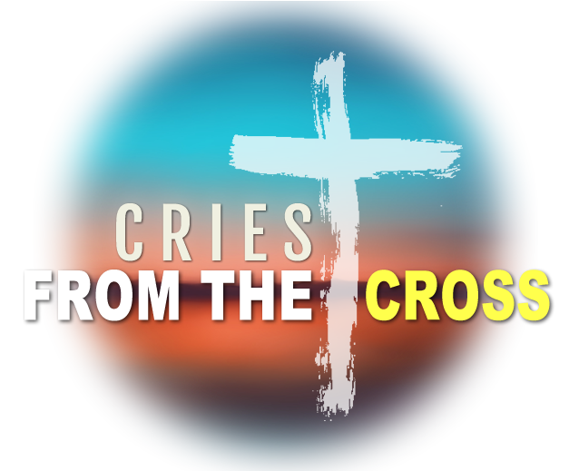
Father, Forgive Them
Luke 23:34

There is _____________________ at the __________________.
- Jesus is the ______________________ Son of God
- Jesus is the ______________________ Lamb of God
- Jesus is the ______________________ Son of Man
You are _______________________!

